**PaNOSC**

**Photon and Neutron Open Science Cloud**

**H2020-INFRAEOSC-04-2018**

**Grant Agreement Number: 823852**

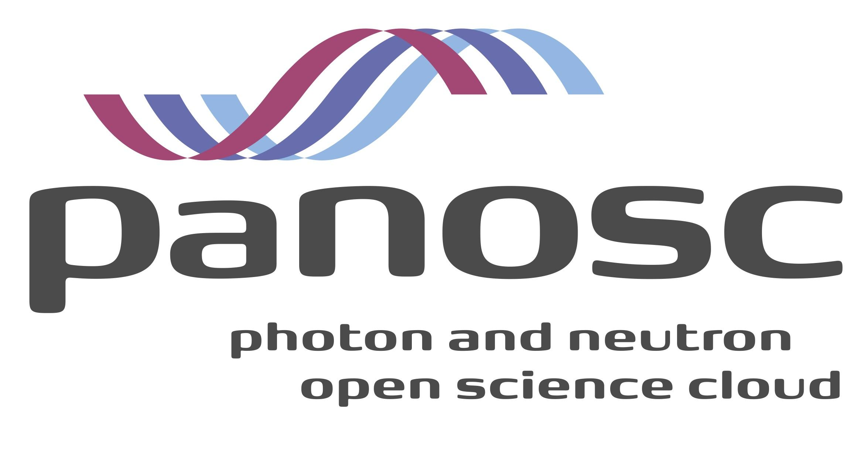

**Deliverable: D1.10 Report of annual workshop 4**

# Project Deliverable Information Sheet

|  |  |
| --- | --- |
| Project Reference No. | 823852 |
| Project acronym: | PaNOSC |
| Project full name: | Photon and Neutron Open Science Cloud |
| H2020 Call: | INFRAEOSC-04-2018 |
| Project Coordinator | Andy Götz (andy.gotz@esrf.fr) |
| Coordinating Organization: | ESRF |
| Project Website: | www.panosc.eu |
| Deliverable No: | D1.10 |
| Deliverable Type: | Report |
| Dissemination Level | Public |
| Contractual Delivery Date: | 30/11/2022 |
| Actual Delivery Date: | 09/01/2023 |
| EC project Officer: | Flavius Alexandru Pana |

## Document Control Sheet

|  |  |
| --- | --- |
| **Document** | Title: Report of annual workshop 4 |
| Version:1 |
| Available at: https://github.com/panosc-eu/panosc and zenodo |
| Files: 1 |
| **Authorship** | Written by: Jordi Bodera Sempere |
| Contributors: Andrew Götz, Tobias Richter, Fabio Dall ’Antonia, Carsten Fortmann-Grotte, Jean-François Perrin, Teodor Ivanonica, Ornela De Giacomo, Thomas Holm Rod, Nicoletta Carboni |
| Reviewed by: Andy Götz, Jayesh Wagh |
| Approved: Jordi Bodera Sempere |

## List of participants

|  |  |  |
| --- | --- | --- |
| **Participant No.** | **Participant organisation name** | **Country** |
| 1 | European Synchrotron Radiation Facility (ESRF) | France |
| 2 | Institut Laue-Langevin (ILL) | France |
| 3 | European XFEL (XFEL.EU) | Germany |
| 4 | The European Spallation Source (ESS) | Sweden |
| 5 | ELI European Research Infrastructure Consortium (ELI-ERIC) | Belgium |
| 6 | Central European Research Infrastructure Consortium (CERIC-ERIC) | Italy |
| 7 | EGI Foundation (EGI.eu) | The Netherlands |

# Table of Content

Project Deliverable Information Sheet 2

Document Control Sheet 2

List of participants 2

Table of Content 3

Executive Summary 3

Introduction 5

Summary of the closing event 6

PaNOSC status12

Summary of progress 13

WP1 - Management 13

WP2 - Data Policy and Stewardship 14

WP3 - Data Catalog Services 14

WP4 - Data Analysis Services 15

WP5 - Virtual Neutron and X-ray Laboratory 18

WP6 - EOSC Integration 20

WP7 - Sustainability 22

WP8 - Staff and User Training 23

WP9 - Outreach/Communication and Dissemination/Impact 24

PaNOSC Executive Board Meeting - 29/11/2022 27

Next steps 28

# Executive Summary

PaNOSC is funded by the H2020-INFRAEOSC-04-2018 call with Grant Agreement Number: 823852. The project started on 1st December 2018 and finished 30th November 2022.

The project advanced according to plan with only minor deviations. Partners and stakeholders met regularly to move the project forward, submitting deliverables, achieving milestones and ensuring that key outcomes of the project are made available in production environments, helping make FAIR data a reality for the Photon and Neutron (PaN) facility users and the EOSC.

Cooperation with ExPaNDS has continued as foreseen until the end of the project, helping the PaN community as a whole.

The closing event of PaNOSC took place 29th and 30th November 2022, during the last two days of project execution, with the aim to showcase the work done, open discussions about continuing collaboration between Research Infrastructures to ensure the outcomes are sustainable and the needs of users are satisfied.

# Introduction

This document summarises the PaNOSC[1] closing event hosted by ESRF[2] that took place on 29th and 30th November 2022. The final event was hybrid in order to facilitate remote or in-person attendance.

This report also covers the recent progress achieved from all work packages.

# Summary of the closing event

The PaNOSC closing event took place on 29th and 30th of November 2022.

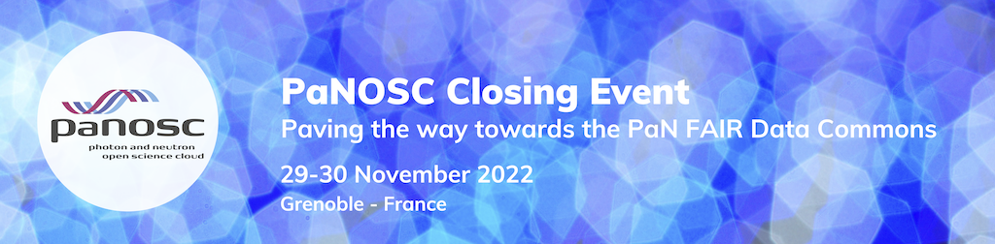

Figure 1: Event banner

This event was aimed to three major stakeholders:

* Project participants
* Users
* Participants in other EOSC[3] projects and initiatives

Given a busy November 2022 event period (EOSC Symposium, EOSC Association General Assembly, etc.) and in order to maximise attendance the organiser committee decided to host a hybrid event, with in-person and remote attendance both possible.

The closing event presented the major results achieved during the four years of project execution, gathering the contributors to discuss about future collaborations and sustaining the tools, software and services developed to make data FAIR[4] at European PaN[5] facilities.

Users presented their vision and desires of a PaN Data Commons, FAIR data and how these could help their research and also improve the way research in general is done.

Discussions between all the participants regarding sustainability, cooperation and future funding opportunities took place, including other cluster projects and EOSC initiatives.

All the presentations are available on the PaNOSC GitHub repository and zenodo:

[GITHUB](https://github.com/panosc-eu/panosc/tree/master/Work%20Packages/WP9%20Outreach%20and%20communication/Presentations/20221129-30%20PaNOSC%20closing%20event) | [ZENODO](https://zenodo.org/record/7390488#.Y4oDrYTMJ6U)[6]

The closing event was organised as a day and a half event that took place during Tuesday 29th of November and the morning of Wednesday 30th November 2022. The event was open to anyone that would register (at no cost) and attracted 65 onsite and 61 remote attendees for a grand total of 126 participants.

The agenda[7] was as follows:

**Day 1- 29th November 2022**

|  |  |  |
| --- | --- | --- |
| **Topic** | **Speakers** | **Schedule** |
| Welcome speech | Andy Götz (ESRF) | 09:15-09:30 |
| VINYL Simulations - post project plans | Mads Bertelsen (ESS) | 09:30-10:00 |
| VISA & Data Analysis - post project plans | Erwan Le Gall (ILL) Fabio Dall’Antonia (XFEL) | 10:00-10:30 |
| Coffee break | | 10:30-10:45 |
| Data Transfer & AAI - post project plans | Jean-François Perrin (ESRF) | 10:45-11:05 |
| E-learning platform and Training Catalogue - post project plans | Andrew McCluskey (ESS) | 11:05-11:30 |
| Federated Search - post project plans | Massimiliano Novelli (ESS)  Tobias Richter (ESS) | 11:30-11:55 |
| Pan data policies & DMPs - post project plans | Andy Götz (ESRF) | 11:55-12:15 |
| Lunch | | 12:15-13:30 |
| Welcome | Vincent Favre-Nicolin (ESRF) | 13:30-13:40 |
| PaNOSC major highlights and vision of the PaN Data Commons | Andy Götz (ESRF) | 13:40-14:00 |
| ExPaNDS major highlights and collaboration with PaNOSC | Patrick Fuhrmann (DESY) | 14:00-14:15 |
| A user perspective: vision on FAIR data for PaN science | Claire Walsh (UCL) John Helliwell (IUCr)  Hans Fangohr (Max Plank) | 14:15-15:00 |
| Round table: users vision compared with RIs achievements | Claire Walsh (UCL)  John Helliwell (IUCr)  Hans Fangohr (Max Plank) | 15:00-15:30 |
| Coffee break | | 15:30-15:45 |
| Building on current projects for future INFRA-EOSC-01-01 for the PaN cluster | Andrew Götz (ESRF)  Giorgio Rossi (NFFA Europe)  Giuseppe Brandino (eXact-lab & NFFA Europe)  Jean-François Perrin (ESRF)  Majid Oursy (SOLEIL)  Nicolas Soler (ALBA)  Patrick Fuhrmann (DESY) | 15:45-16:45 |
| ESFRI + EOSC Association on EOSC sustainability and future | Ute Gunsenheimer  (EOSC Association) | 16:45-17:15 |
| Executive Board Meeting (*closed event*) |  | 17:15-18:15 |

**Day 2 - 30th November 2022**

|  |  |  |
| --- | --- | --- |
| **Topic** | **Speakers** | **Schedule** |
| Coffee | | 08:45-09:00 |
| What EOSC Science Clusters funding changed for us | Giovanni Lamanna (ESCAPE)  Niklas Blomberg (EOSC Life)  Franciska de Jong (SHHOC )  Andreas Petzold (ENVRI FAIR) | 09:00-09:45 |
| EOSC ecosystem and its sustainability | Bob Jones (CERN) Dale Robertson (EGI) | 09:45-10:30 |
| Coffee break | | 10:30-10:45 |
| What PaNOSC changed for us | Alessandro Olivo (CERIC)  Andrew Götz (ESRF)  Erwan Le Gall (ILL)  Luis Maia (XFEL)  Teodor Ivanoaica (ELI)  Thomas Rod (ESS) | 10:45-11:45 |
| Closing remarks | Andrew Götz (ESRF) | 11:45-12:15 |
| Lunch onsite | | 12:15-13:30 |

The event started as planned at 09:15h, however a minor technical issue prevented the online participants from following the first five minutes of the event, during which Andrew Götz as project Coordinator went quickly through the project and the event itself.

The welcome speech was followed by sessions by the different technical WPs in the morning during which they explained their work and the post-project plans. This created a morning block of sessions that looked at PaNOSC very closely while the remaining sessions of the two day event were of more general and broad interest about the EOSC.

The first of such sessions was delivered by Mads Bertelsen and focused on the WP5 - ViNYL. Mads reminded everyone of the WP aims, the different simulation software and streams of work and how all contributors are interested in continuing supporting the software.

The second session focused on WP4 - Data Analysis and had two small presentations, with Erwan Le Gall giving an overview of VISA and Fabio Dall’Antonia going through the WP structure, division of work and how the different outcomes of the WP have been adopted by the partners.

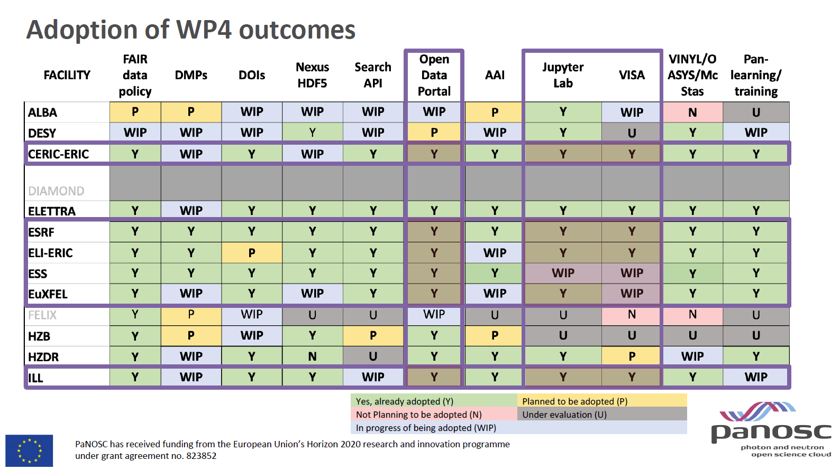

Figure 2: slide by Fabio Dall'Antonia

Fabio also reported plans for the future and explained that straight after the closing event the different contributors to VISA will hold a meeting to try to reach an agreement for how to collaborate together going forward.

Jean-François Perrin reported the status of WP6 with regards to

* Data Transfer: after some tests further work has been identified
* AAI: is working well and we must build on it
* VISA deployment: challenges, solutions and future perspectives

Andrew McCluskey presented the session on WP8, focusing on the training catalogue and e-learning, highlighting the achievements (e-neutrons.org has evolved into <https://e-learning.pan-training.eu/> which is easier to maintain and has additional functionality e.g. integration of Jupyter notebooks for training purposes), showing statistics about usage and revealing what will happen next with the tools.

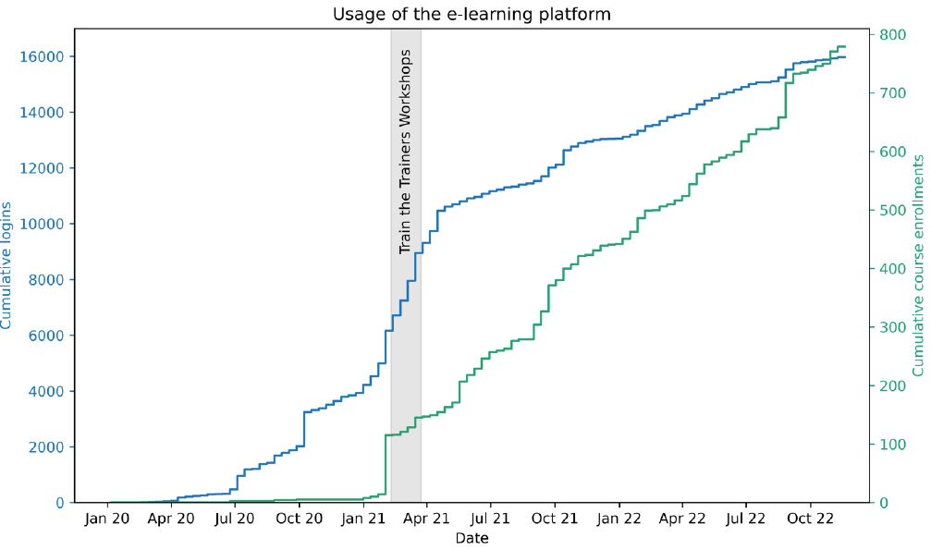

Figure 3: slide from WP8 session by Andrew McCluskey

Massimiliano Novelli presented the post project plans for the WP3, focusing on the key outcomes (integration with B2Find and OpenAIRE), the PaNOSC Data Portal (<https://data.panosc.eu>) and the Federated Search. Massimiliano reported plans to improve curation of datasets, maintain and improve the scoring of the search and collaborate with LENS and LEAPS working groups on data.

Andrew Götz presented the last session of the morning, focusing on the future developments for the WP2:

* continuing the Data Policy implementation
* DOIs: accessing and citing them
* Improve DMPs and collaborate with DS-Wizard
* Continue training data experts

A short welcome address by Vincent Favre-Nicoling for those that arrived in the afternoon was followed by a presentation by Andy Götz on the topic of major highlights of the project, like the use cases (<https://www.panosc.eu/all-use-cases/>), the adoption of outcomes or the awareness raised on the topics of FAIR data and Data Management.

Patrick Fuhrmann followed with a session on the PaN community evolution over the years and the common analysis tools used by the PaN sources and explaining how further collaborations between PaN sources (e.g. VISA) is being worked out.

A long session followed with presentations by Claire Walsh, Hans Fangohr and John Helliwell covering topics as diverse as the Human Organ Atlas (<https://human-organ-atlas.esrf.eu/>), Jupyter notebooks, Binder, FAIR data and the approach followed at the IUCr (https://www.iucr.org/) which included a round table where they looked at their requirements as users / experts on the requirements from their scientific communities compared with the outcomes from PaNOSC.

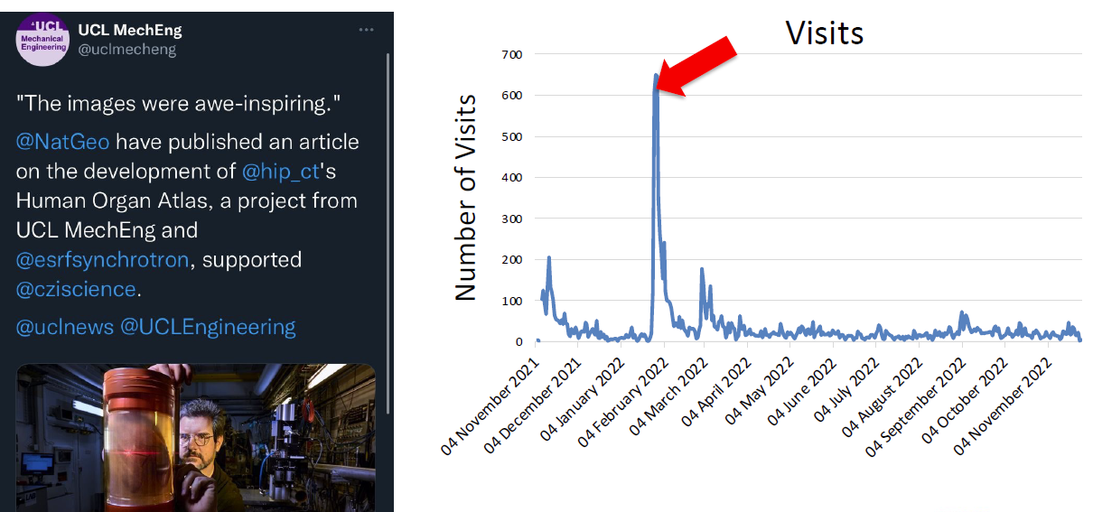

Figure 4: detail of a slide from Claire Walsh's presentation

After a well-deserved coffee break, partner representatives showcased future funding opportunities (e.g. HORIZON-INFRA-EOSC-2023-01-01) and the consolidation that must take place.

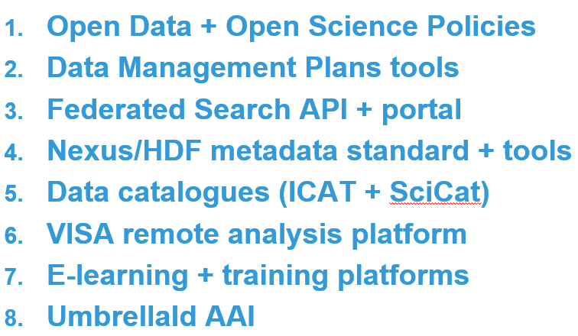

Figure 5: slide showing the main outcomes from PaNOSC and ExPaNDS that should be consolidated as part of EOSC

Ute Gunsenheimer (Secretary General of the EOSC Association) delivered the last open session of the first day, focusing on the work the EOSC Association is doing, EOSC sustainability, future plans for funding and the strategy to continue supporting and delivering a functional EOSC in the future.

The final day of the closing event started with a session dedicated to the 4 science cluster projects with presentations by the coordinators Andreas Petzold, Franciska de Jong, Giovanni Lamana and Niklas Blomberg who explained the achievements and changes made on their science clusters thanks to the EOSC funding. Andreas represented ENVRI-FAIR and explained the particularities of the Environmental RIs, the members of the cluster, past projects and key achievements. Giovanni introduced ESCAPE, the data-lake concept and their virtual research environment. Franciska followed with SSHOC and introduced the SSH Open Marketplace. Niklas completed this session with his talk about EOSC-Life and the reusable services for data management and analysis.

The next session focused on the EOSC ecosystem and sustainability. Bob Jones went through the Strategy Research and Innovation Agenda (SRIA) of the EOSC, focusing on the upcoming phase, the architecture of the Minimum Viable EOSC (MVE), the EOSC Future project, ongoing procurement action, the EOSC Association and the EOSC Steering Board.

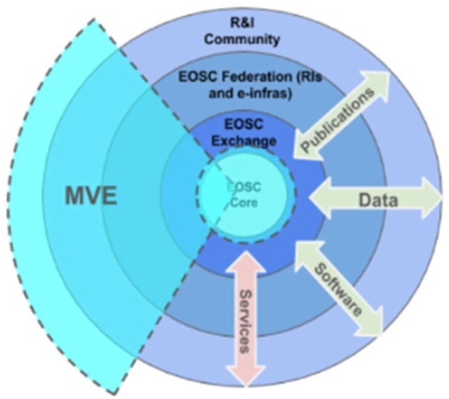

Figure 6: detail of the EOSC architecture from Bob Jone's presentation

Dale Robertson made a presentation on the Interim Progress Report of the Financial Sustainability Task Force of the EOSC Association which includes proposals for the EOSC Core funding and governance; the EOSC Exchange financial sustainability and the data federation.

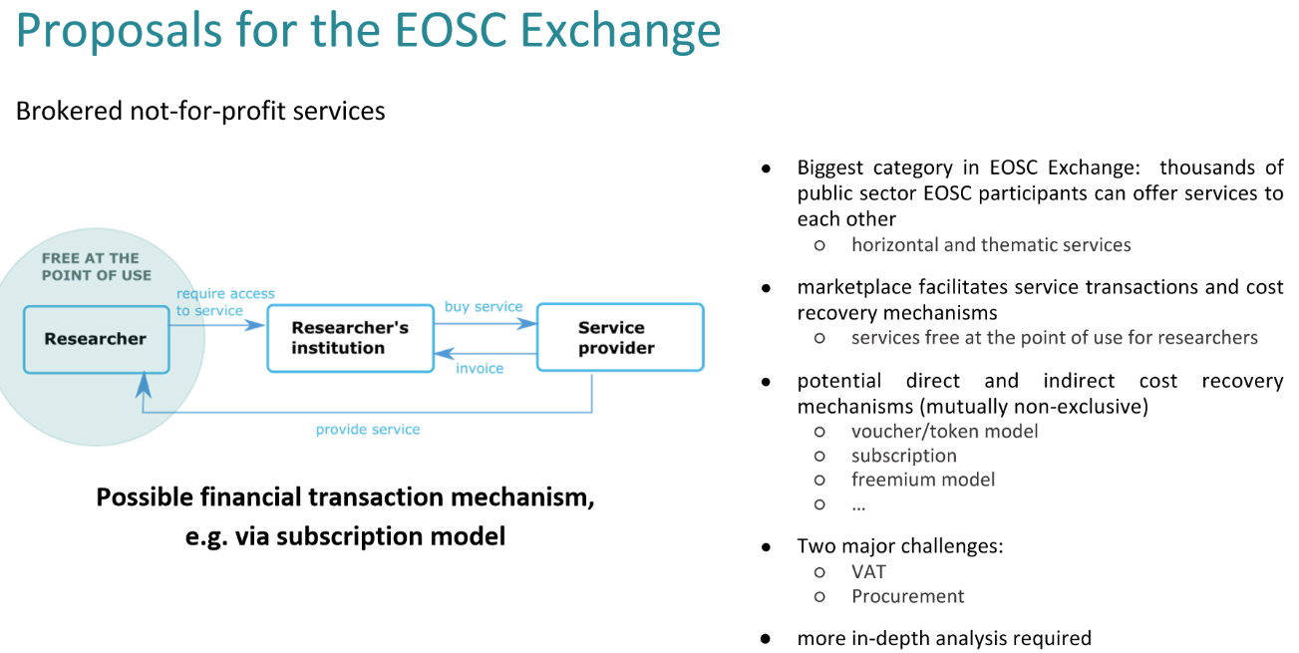

Figure 7: slide from Dale Robertson's presentation

A session followed with all the PaNOSC partners reporting the impact the project had on them and what have been the main changes thanks to PaNOSC and the EC funding, during which new data policies, data catalogs, availability of data, metadata, simulations, data management plans, AAI and VISA were listed again and again by all partners, showing a good alignment and collaboration between the different partners.

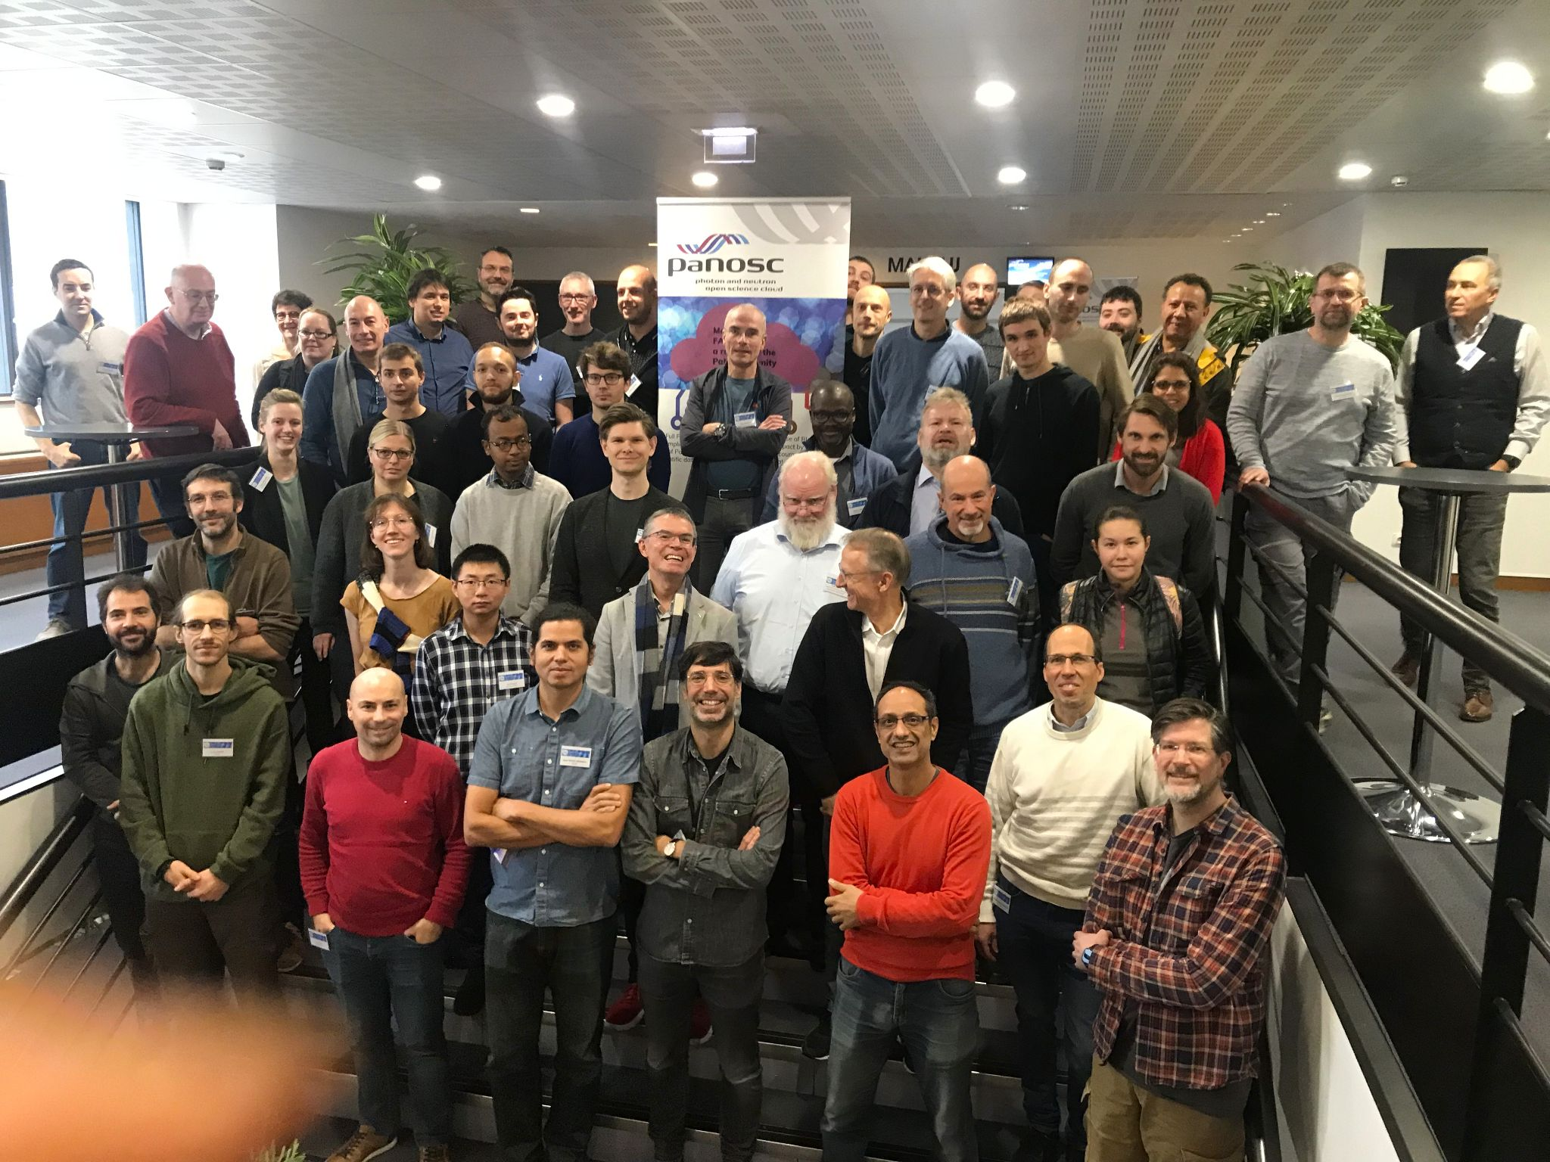

Figure 8: attendees picture on teh last day of the closing event

Andrew Götz closed the event by comparing a presentation made by PaNOSC’s first Project Officer four years ago during the kick-off meeting with the current situation and how the current plans should evolve in the future.

# PaNOSC status

## Summary of progress

At the time of finishing writing this document PaNOSC has closed, with its final event in the very last two days of project execution and project contributors assembling the final deliverables to be submitted. The only remaining work is related to the final reporting period report, certificates of financial statements and other small items.

PaNOSC has delivered a significant contribution towards building the EOSC and creating a PaN Data Commons that makes a difference for researchers and RIs. A testimony to the usefulness and engagement of PaNOSC with the PaN community are the use cases collected in https://www.panosc.eu/all-use-cases/ and the fact that outcomes are in production and most RIs intend to continue supporting them.

### WP1 - Management

Following the submission of D1.9 31st of May 2022, the Management WP continued with its recurrent activity:

* Organising and reporting on the Project Management Committee (PMC) meetings[8]
* Informing the Executive Board and organising its last meeting
* Following-up the work done in other WPs and their coordination
* Project monitoring
  + checking progress and issues with regards to submitting deliverables and achieving milestones
  + reviewing the project’s financial situation
  + following up the partners contribution to the project
  + providing ad hoc support to WP leaders and partner organisations
  + providing guidance with regards to EU funding rules
* Communicating with the Project Officer
* Coordinating work with ExPaNDS, ensuring both projects are aligned and inform each other of their activities and plans
* Representing PaNOSC at different meetings/conferences (e.g. EOSC Symposium) jointly with WP9
* Liaising with other EOSC initiatives(EOSC Association, EOSC Future and other cluster projects)
* Administrating the mailing lists
* Following-up the actions taken with regards to recommendations from the last periodic report
* Reviewing deliverables and submitting them

On top of these actions, WP1 also:

* led the effort to produce a Grant Agreement amendment
* contributed to the organisation of the final PaNOSC event
* started the work for the final periodic report

The PMC meetings have taken place regularly on a bi-weekly basis (excluding holiday periods), with weekly meetings when it has been required. The agenda and minutes of these minutes are publicly available in GitHub, showing how these meetings have helped building working relationships between people, keeping WPs coordinated and everyone informed. ExPaNDS has been invited to these meetings and reported to them, ensuring good information flow between the two projects.

Some deliverables and milestones have been late, however at the time of writing this deliverable the WP1 leader is confident that all of them will be submitted before the final periodic report and that all the objectives of the project have been achieved.

### WP2 - Data Policy and Stewardship

Although WP2 officially ended at the end of 2021 work has continued in the areas of Data Policy and Stewardship. A major update of the EuXFEL Scientific Data Policy has been prepared and presented to the Detector Advisory Committee. The updated data policy addresses the issues of huge data volumes and Data Management Plans (DMPs). ESRF deployed a service for DMPs for all proposals based on the DS-Wizard tool and software developed by ESS as part of WP2. The service fills in the DMPs automatically to inform users of what the facility provides in terms of data management. In the future the service could become a requirement for experiments depending on the data volumes or complexity of the data analysis. ELI ERIC rolled out DMPs as part of their first call for proposals. CERIC ERIC implemented a DMP service based on DS-Wizard. ILL started prototyping a service for DMPs. The PaNOSC partners wrote a paper describing how they have implemented and deployed DMP services and submitted it for publication in the Data Science Journal special issue on DMPs.

WP2 members continued to provide training on FAIR data management to the community. A course on FAIR data management was given as part of the PaNOSC Summer School held in Szeged (Hungary) in September. A similar course is planned for the African School on Light Sources in 2023. The training of data stewards will continue.

The work of WP2 will continue in all facilities as they update their data management practices to handle the challenges of huge data volumes and the evolving practices of FAIR data. Training will be an essential part of the future too in order to spread the best practices of FAIR data management in the PaN community. The PaNOSC partners will collaborate with the developers of DS-Wizard to make DMPs even more user friendly. PaN facilities will certify their data repositories with Core Trust Seal and register their data policies with FAIRsharing.org so they can be recommended to scientists by scientific journals as trustworthy data repositories for scientific data.

### WP3 - Data Catalog Services

In this reporting period, the work package had one remaining deliverable to submit: D3.4 Implementation Report from Facilities, which was submitted on time. This final deliverable summarises the per-partner progress towards delivering integrated services as part of the European Open Science Cloud. It also concludes the per-partner integration efforts to make cataloguing part of their data workflows. The partners took the opportunity to iterate the progress to make local API implementations and data repository mappings compliant with the common search API that was the subject of previous work. At the point of submission, 3 (ESRF, ESS, CERIC) out of the 6 PaNOSC partners had been able to deploy a search API that complies with the agreed minimum functionality. The remaining 3 have successfully implemented this as well in the time after the submission and have joined the federated search service (with the exception of ELI due to the lack of public data).

Even in this phase of the project much effort was still devoted to technical aspects. For example to achieve compliance with the API and to provide consistent scoring (ranking) of results. Consequently the curation of data has lacked some attention and only a fraction of the catalogued datasets are fully compliant with the common mapping for parameters, techniques, roles, etc. That results in a federated service that is technically well developed, but the amount of useful data that can be explored is quite imbalanced between partners. Towards the end of the project some effort has been put towards improving that situation. This culminated in a joint meeting with the ExPaNDS WP3, hosted by Soleil (https://indico.psi.ch/event/13458/). In addition to the preparation of a demonstration “playbook” that workshop focussed on sustainability of the outcomes of both WP3’s as well as the immediate and strategic plans of partners to gear up for the PaNOSC closing session in Grenoble. For the aspect of sustainability three main areas have been identified: services, technology (source code projects), and standards. This would also structure and summarise the main achievement of WP3 - most of the jointly with expands:

* Services:
  + OAI-PMH endpoints
  + search API endpoints
  + federated API back end
  + data portal
* Technology/Code
  + OAI-PMH connectors to local data catalogues
  + search API connectors to local data catalogues
  + generic and local scoring implementation
  + federated API backend implementation
  + data portal front end
* Standards
  + PaNet
  + progress on NeXus
  + agreed keywords for federated search and data curation

### WP4 - Data Analysis Services

Work within the period since the last report focused on the advancement, respectively completion, of the VISA service deployment at the sites of the partner RIs. Development of the VISA web application and its microservices was continued by ILL colleagues, leading to the release of version 2.4 in late October. This most recent version features virtual machine instances that can be spawned on different parallelly running cloud providers, giving administrators more options when, for instance, migrating the service. Moreover, the feature of sharing instances between users was extended: a user has now the option to share his instance with another user such that the colleague may work on the shared instance even if the owning user is not connected him-/herself.

VISA is meanwhile in official production at ESRF, with the expansion of the user range to all ESRF beamlines and thereby widening of the software portfolio installed within the VM images, respectively mounted via CVMFS clients in Singularity containers. Support of Windows images is sought after; this is work in progress.

At European XFEL, VISA on production infrastructure was made ready for usage with open data, as accomplished by mounting a proposal with example data sets. This proposal represents a collection of open data from a range of user beam-times as well as commissioning experiments at the different European XFEL instruments. The ETL process was further adapted to reflect the respective metadata from the facility’s catalogue.

The ongoing maturation of VISA was demonstrated both at the PaNOSC/ExPaNDS meeting in Prague (June) and at a dedicated PaNOSC/ExPaNDS online workshop on VISA in September, organised by colleagues from SOLEIL. The workshop consisted of a user-experience session addressing beamline scientists (and first facility users), a technical deployment session addressing IT staff of existing and future facilities deciding to adopt the VISA service, and a round-table discussion where collaborating sites decided to issue a memorandum of understanding for future collaboration on VISA development and maintenance. With respect to the collaborative development, it was agreed that such efforts will not be based on code forks, but rather stay within one repository and be based on commonly reviewed and accepted feature commits.

The PaNOSC search portal at data.panosc.eu has seen the maturation of the web frontend from demonstration status to production, and on the back-end side, the inclusion of a growing number of partners to the federated search, by means of connecting the federated API (development driven by ESS within the WP3 scope), to search endpoints at data catalogues from five of the PaNOSC RIs and two ExPaNDS RIs. All of the participating partners have installed and adapted the implementation of a scoring algorithm (ESS, WP3) for a meaningful sorting of aggregated results. A recent addition to the portal frontend allows for the provision of service URLs of a facility within the returned metadata entry of a search result. As an ongoing work, DOI landing pages of the facilities, respectively direct target links, will be made ready to lead users from the search portal to dataset-specific analysis service pages like JupyterHub (with SLURM) or VISA. A demonstrator of this achievement is aimed to be put in place just at the end of the PaNOSC project, representing deliverable D4.4.

ESRF developers have complemented the portfolio of service components around the web viewer H5web for the visualisation of HDF5 files in a browser. This includes *h5grove*, a Python package to setup a cloud service backend, which in practice enabled the integration of H5web to the ESRF data portal, and *h5wasm*, a WebAssembly library which enables the exploration of local HDF5 files directly in the browser (reading and writing from Javascript) without the need to connect to a separate server. The *h5wasm* development leveraged a VSCode extension using H5Web to visualise HDF5 files in that IDE.

Key outcomes of this WP during the whole project

1. *VISA for cloud-based data analysis*

The main outcome of the PaNOSC WP4 is the web-service VISA (Virtual Infrastructure for Scientific Analysis) developed by colleagues from the ILL. VISA consists of a web-frontend application and several microservices to spawn and manage virtual machines (VMs) on a cloud cluster infrastructure. While this concept has originally been designed for the OpenStack technology, VISA includes also an interface for other providers, such as ProxMox. The data analysis services within a spawned instance, i. e. VM image, run either on a remote desktop session using the Apache Guacamole gateway, or on a Jupyter notebook server. VM sessions can be shared between users for the benefit of real-time collaboration on data analysis tasks.

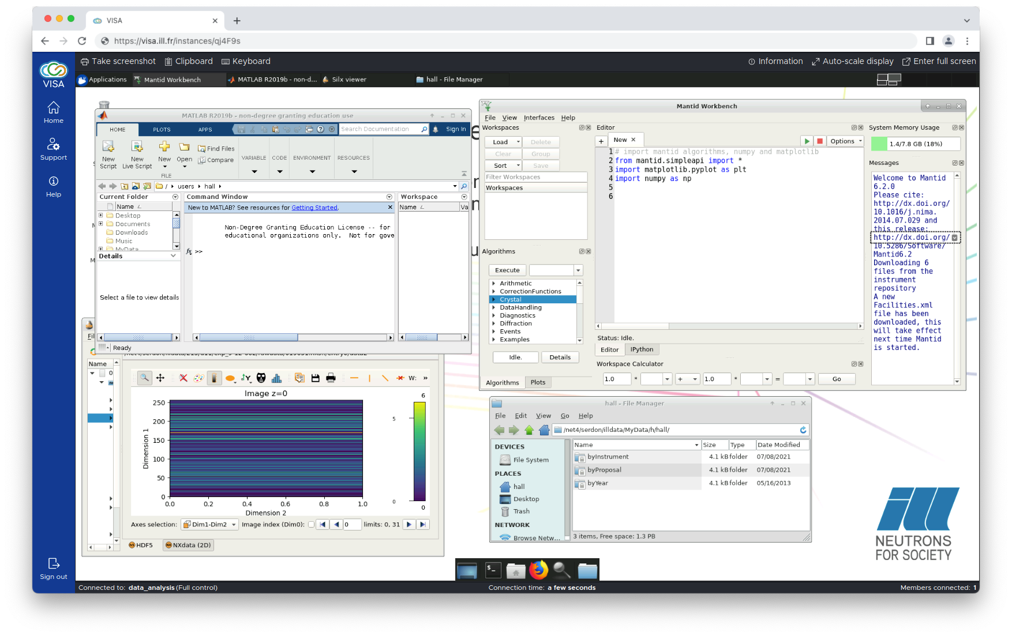

Figure 9: VISA desktop

PaNOSC partners have set up appropriate cloud provider infrastructure and have deployed VISA as well as virtual machine images, on production or demonstration level, packed with software appropriate for the needs of the respective facility and their user communities. VISA is in production at ILL (visa.ill.fr) for more than two years and has had more than 1100 users so far. For the neutron community it comes bundled with GUI software such as Mantid to be run in remote desktop sessions. VISA is in production at ESRF since May 2022, has first been used by two beamlines and is currently in the phase of being rolled out for use at all beamlines. European XFEL, with the help of DESY colleagues, have deployed VISA using continuous integration with Kubernetes, for use on the DESY OpenStack cluster. The main purpose of the current service is re-use of open data, providing a collection of 60 representative data sets from real user beam-time or instrument commissioning proposals. Other partners have deployed VISA on production or test infrastructure and are in the process of making it ready for users. All of the PaNOSC RIs are looking into use of Singularity containers and mounting of software folders with CVMFS for the sake of more lightweight virtual machine images.

*2. Jupyter notebook service infrastructure for remote data analysis*

JupyterLab/Hub is an infrastructure that provides a multiuser implementation of the Jupyter Notebook, a web application “ecosystem” allowing users to create and share documents containing live code (via kernels for Julia, Python and R), equations, visualisations and text annotations. JupyterHub lets users run notebook servers on shared hardware, where resource-managing backends such as SLURM can be employed. Thereby one takes advantage of already existing Graphics Processing Unit (GPU) or High-Performance Computing (HPC) resources. All partners provide a remote infrastructure to serve data analysis with Jupyter. In case of European XFEL (<https://max-jhub.desy.de>) and ESRF (<https://jupyter-slurm.esrf.fr>) these are dedicated SLURM cluster-based services. ESS offers the PaN training platform (<https://e-learning.pan-training.eu>) which includes access to dedicated Jupyter ecosystem resources via SLURM. ILL caters Jupyter notebook servers within the VISA virtual machine instances. At CERIC, JupyterLab instances are available to each beamline via the user office system VUO/Rafec (<https://vuo.elettra.eu>), running inside Singularity containers on edge devices.

*3. Data analysis and HDF5 file inspection software/services*

All of the PaNOSC partner RIs make use of HDF5 files to store scientific data, as either major or even exclusive data container format. Software dealing with data of this kind, as developed in the PaNOSC context, has been registered to the PaNdata Software Catalogue (<https://software.pan-data.eu/>). European XFEL have developed the Python frameworks EXtra-data and EXtra-geom for data analysis from HDF5 files, taking specifics of the detector geometries at instruments of the facility into account. The h5glance tool is a more generic HDF5 inspection frontend for the command line, and with a plug-in to Jupyter notebooks. Both ESRF and CERIC have developed frameworks for HDF5 file exploration and visualisation that are embedded to web-services. The ESRF tool h5web is a viewer for both navigation in the hierarchical HDF5 structure and visualisation of data sets in several 1D and 2D graphs. Plugins and extensions around this viewer allow for embedding of this framework to web servers, client applications (local browser or VSCode, for instance) and to notebook code in JupyterLab. A h5web backend enables display of HSF5 files belonging to open proposal data directly in the ESRF data catalogue. Likewise, h5nuvola developed at CERIC/Elettra is a modular framework enabling cloud-based exploration of HDF5 file contents, including graphical visualisation of various kind. It is embedded to the Virtual Unified Office (VUO) at Elettra so that open data can be inspected interactively.

*4. Open data search portal*

The open data search portal is the outcome of a collaboration with WP3 colleagues, adding a web front-end to the federated search API, which connects to data catalogue APIs for search endpoints. Searches can combine text queries with filters such as experimental techniques and physical parameters of the experiments.

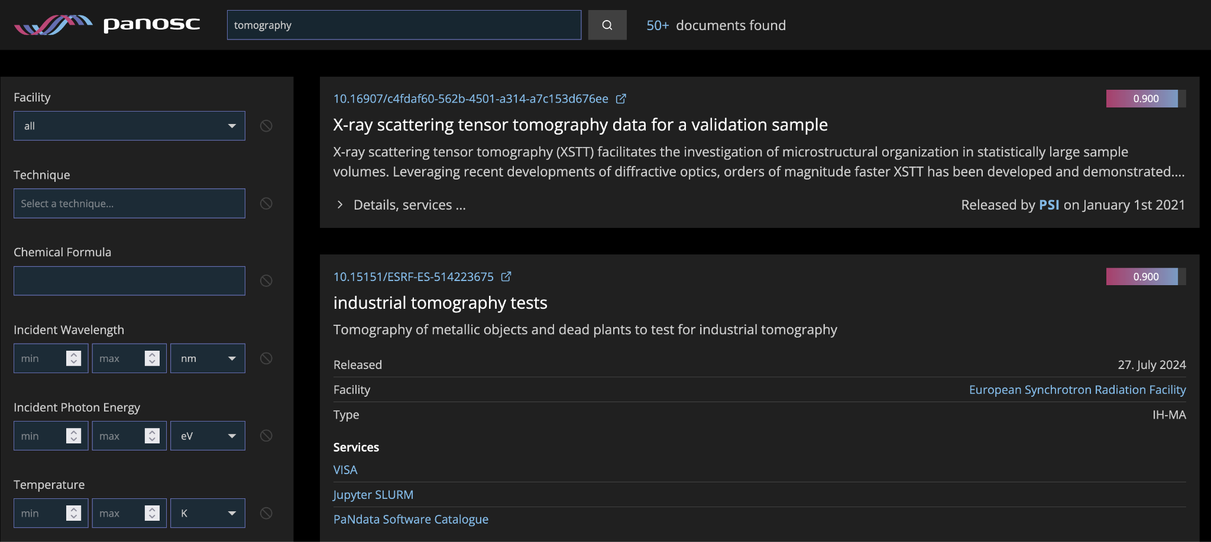

Figure 10: The matches on open data (proposal and experiment level)

The matches on open data (proposal and experiment level) are scored for a meaningful sorting of aggregated results. Retrieved entries as displayed in the portal front-end contain links to both the data catalogues DOI landing pages and data analysis services for the re-use of this data.

### WP5 - Virtual Neutron and X-ray Laboratory

Work in WP5 focussed on the achievement of the final deliverable D5.4 and completion of all tasks. After releasing the core simulation APIs and usage examples in D5.3 and MS5.3, respectively, the most recent releases that constitute D5.4 have been prepared with special attention on interoperability of the various components, such as libpyvinyl, the core API library, the instrument database API, simex-lite, the photon experiment simulation API, McStassScript, the neutron simulation API, and Oasys, the x-ray optics GUI.

Libpyvinyl: Is the core simulation API library that provides all abstract base classes from which specialized simulation APIs derive their classes in order to provide a harmonized simulation user interface.

The latest release of libpyvinyl contains numerous bugfixes and feature enhancements that make simulations more interoperable, and address shortcomings with respect to the compatibility with neutron simulations via McStasScript, x-ray simulations with SHADOW as well as with InstrumentDatabase and the InstrumentDatabaseAPI (see below).

Development of libpyvinyl was led by EuXFEL with major contributions from ESS and ILL. ESRF and ELI-ALPS contributed to the testing of the library and its derived simulation Calculators.

The Instrument database and its API constitute two major achievements in WP5 not foreseen at this level in the beginning.

Background: Facility users have hardly access to complete and up-to-date instrument descriptions to run sample simulations and they are diﬀicult to manipulate for a user not expert in the specific simulation software. While libpyvinyl offers the high-level interface to harmonize the interaction with an instrument described with different simulation softwares, the instrument database has been designed to collect in a central place instrument descriptions created with softwares adopting the libpyvinyl API. Users are then able to access the instrument with few lines of code and run the simulation with a set of implemented samples (expandable). The instrument comes with the set of high level parameters defining the settings of the instrument that the user is supposed to be able to manipulate at the facility for the data acquisition, while all internal complexities are hidden.

The structure of the database have been defined and a dedicated API is available to list its content and access the required instrument description. Only few pilot instruments are described and are supposed to be used as examples for implementing new instruments. A complete validation of the instruments has not been performed.

The instrument database and its API designs have been leaded by ILL and co-designed with ESS and EuXFEL. It is envisioned several ESS instruments and sample environments will be submitted to the database soon, further testing and extending the system as needed.

#### Neutron simulations (ESS, ILL)

For neutron scattering, the McStas package is the standard tool for instrument simulations, yet it has a specialized user interface built on the C programming language. McStas has a sister project called McXtrace that simulates X-ray instrumentation. The main contribution from the ESS have been the McStasScript Python API that allows nearly full access to McStas/McXtrace features through an elegant Python interface (tasks T5.2, T5.3, and even offers some functionality in addition to the basic package. In its latest release, McStasScript is now compatible with libpyvinyl, such that instruments can be defined via inheritance from the libpyvinyl base classes, thereby exposing the harmonized user interfaces to instrument parameters to the user.

At ILL, WP5 has contributed to the development of a digital twin prototype based on the McStas neutron simulation engine. The goal is to interface Mcstas simulations of an instrument from a research facility to the data acquisition system in order to offer to users the same experience as during their experiments. Users are then able to prepare proposals, preparing in advance their experiments optimizing the instrument settings to maximize their scientific outcome and reduce beam time needed. Further details on McStasScript and the digital twin prototype are given in the Deliverable D5.4 document.

#### Synchrotron Radiation Simulations (CEiRC-ERIC, ESRF)

OASYS (OrAnge SYnchrotron Suite), an open source environment for modelling X-ray beamlines and experiments has seen major improvements via contributions from CERIC-ERIC and ESRF. During the PaNOSC project, we have addressed several different topics. A detailed account is given in the Deliverable D5.4 report. Here, we briefly list the major achievements:

* Wiser:

All contributions to the OASYS part described below come from CERIC-ERIC and ESRF.

Wiser is a new package for wavefront propagation calculations based on Python implementation of WISE calculation code which stemmed from and is still maintained by Elettra Synchrotron. Wiser has been performance optimized to allow X-ray mirror simulations in reasonable times in interactive Oasys sessions, more optical elements are now supported and work on a Wiser GUI widget has started.

COMSYL (COherent Modes for SYnchrotron Light) is a software package to perform numerically the coherent mode decomposition of undulator radiation in a storage ring. This numerically demanding tool is now supports the SLURM scheduler at ESRF. Most importantly, a reimplementation of COMSYL in python is now fully integrated in Oasys. The COMSYL addon has received a number of updates.

SHADOW, the main raytracing engine in Oasys, and the corresponding add-on ShadowOui have been upgraded to allow simulations for monochromators using crystals with high d-spacing, which is of particular interest for storages-rings producing soft X-rays.

CERIC-ERIC and ESRF have contributed a total of 5 Use Cases to the PaNOSC website. More details are provided in the D5.4 report.

#### 

#### X-ray laser experiment simulations

SimEx-Lite is the core package of the SIMEX platform providing the calculator interfaces and data APIs. It can be seen as a prototypical implementation of the object oriented approach to defining simulation APIs starting from an abstract base class as well as concrete classes that define interfaces to data and parameters provided by libpyvinyl. Simex-lite and SIMEX are maintained at EuXFEL.

### WP6 - EOSC Integration

The work during the last reporting period was mainly focused on completing the 3 different activities (AAI, VISA deployment support and the evaluation of the procurement of commercial cloud services) still actively ongoing and preparing the project end.

By working with the EOSC-Future project, UmbrellaID was one of the first scientific community AAI to join the EOSC AAI federation. This represents a genuine achievement for PaNOSC. It concludes 3 years of work in PaNOSC to adapt the community AAI infrastructure and organisation to the model decided for EOSC. At present, all PaNOSC community services benefit seamlessly (i.e. without need to adapt the services) from this integration.

While the development of VISA in terms of functionality and code took place in WP4, WP6 was in charge of supporting the deployment of the underlying infrastructure for the different partners. The initial infrastructures, based on the OpenStack cloud computing platform, were mainly defined to support the creation of the virtual machines (VM) with CPUs and RAM capacities. With the advancement of the deployments in the RIs, it became evident that computing GPU and access to HPC cluster resources were also necessary to fit the needs of users. WP6 has addressed these needs and integrated these types of resources in VISA capabilities when it was necessary, typically at the ESRF A40 GPUs are now available for selected beamline users and a small HPC cluster has been setup to allow running software that necessitate parallel computing infrastructure. VISA was introduced as an additional compute infrastructure to be managed by RI teams. To facilitate the management of the solution WP6 investigated software provisioning solutions. After discussion with the other science clusters, we adopted the approach used in the ESCAPE community. Software are made available to the VM through a CVMFS infrastructure and are packaged within singularity containers. This approach not only simplifies the management of software for VISA and other compute resources but also authorises the use of these software without additional preparation or specific knowledge beyond the premises of the RIs. It also facilitates the preservation of legacy software that could still run on modern systems. The software provisioning topic is discussed in length in the deliverable 6.5.

Data transfer solutions have been explored by the WP6 partners to fit the needs of 3 use cases described hereafter.

|  |  |  |
| --- | --- | --- |
|  | Use cases | Data transfer solution retained |
| 1 | A RI wants to archive its experimental data in a remote data centre. | Rclone |
| 2 | A facility user wants to transfer a large dataset from an RI’s archive to a remote computing centre or her or his home pc. | Globus |
| 3 | A user wants to access a data analysis service, data has to be available “transparently”. |  |

The 1st and 2nd use cases have found solutions that are largely adopted by the community at the end of the PaNOSC project, they are described in deliverable D6.1[9]. The 3rd use case remains largely unanswered as it needs a global approach at the level of EOSC. This use case requires service composability where data from a community repository needs to be accessed and processed on a 3rd party operator infrastructure. In 2022, there is still a gap between the mechanisms to access and authorise data access in the communities and the solutions envisaged at the scale of EOSC. We hope to close this gap in EOSC-Future or in future EOSC related projects as this is a key element for service composability.

The software catalogue of the PaN community <https://software.pan-data.eu> has been updated and functionalities align to the needs following an initial community survey.

A commercial cloud procurement evaluation was made during the last year of the project. This work highlighted some procurement difficulties between the procurement rules in place in the RIs and the commercial model proposed by the cloud providers. While this environment offers an extensive set of technical solutions and resources for scientists. It also stresses the need of IT specialists to support scientists in their work in order to get the full benefits of such a vast environment. Deliverable 6.5 reports on this evaluation.

Working together with the support of GÉANT, EGI and its third party organisations has greatly helped the PaN community to be better prepared and integrate services into EOSC. The question of service compatibility beyond the scope of the community was addressed in the work on data transfer. It yet needs to be handled with a comprehensive cross-community approach, similarly to what has been achieved for the AAI question.

### WP7 - Sustainability

During the period covered in this report, WP7 focused on following the project’s evolution to understand how to better tackle the sustainability of the outputs. This was the time when a lot of interaction with external stakeholders was needed, also to ensure the sustainability strategy was suitable, considering the context. There had been discussions about PaNOSC sustainability in different environments, at European, national and PaN level. At the European level, following the GA of the EOSC Association at the end of May, PaNOSC explored with the Association the most effective ways to collaborate in the future. PaNOSC also interacted with the other clusters participating to regular meetings where the continuation after these projects was addressed. In addition to the exchange of good practices, common solutions across cluster were explored and proposed to be developed in the upcoming calls (Horizon Europe).

A considerable amount of effort in this semester went to the preparation and execution of two events: the satellite event at ICRI and the final event, described also in the introduction of this document and elsewhere. One panel at the ICRI satellite event focused on the EOSC Data Federation sustainability, acknowledging the important role of the clusters as a leading example in what the data federation should be. The panel involved the five clusters (PaNOSC, ENVRI, EOSC LIFE, ESCAPE and SSHOC) and was moderated by the co-chair of the EOSC-A working group “Financial sustainability of EOSC”. The event, hybrid, counted with many online participants and was followed by a rich discussion, after the clusters presented their vision on the data federation and their contribution to it. This was followed by another panel on Sustainability models for the PaN Data Commons session, involving PaNOSC, ExPaNDS, LEAPS and LENS. These initial discussions led to more targeted ones during the PaNOSC final event, where again all clusters where invited to contribute to a common vision and to explain what the cluster projects had brought for them, and also representatives from the same EOSC-A task force took part, the co-chair Dale Robertson and the EOSC-A board member (liaison of this TF) Robert Jones. After this, all project partners presented how the PaNOSC project contributed to improve their data management practices and policies, giving the basis for the following discussions on the sustainability of these outputs.

At the national level, all facilities were engaged in the development of national policies. Participating in these discussions was important, since the data policy and data management practices of our facilities will need to be compliant with the policies of the country where the facilities are located, or even more complicated, compliant with all the stakeholders represented, since all PaNOSC facilities are international. The involvement in the conversation at the national level has also been facilitated by the close interaction between PaNOSC and ExPaNDS, where national facilities are gathered. PaNOSC partners were also very active in steering the discussion at the level of the European cluster of Photon and Neutron facilities and the organisations representing these facilities, LEAPS and LENS. Many aspects of the sustainability of the PaNOSC and ExPaNDS achievements were discussed in these two organisations, and in the last year mostly jointly. This is the setup proposed to follow the path for sustainability in the future, after the project ends, and the MoUs that are being discussed are being brought forward mostly in this joint LEAPS+LENS working group. Two of the PaNOSC Partners, ELI and CERIC who are not included in these organisations take part in the meetings as observers and will keep the collaboration running actively, unless the decisions taken by the members of this group are against their interest.

Overall, this work package has delivered four documents, of which one was mostly for internal use (identification of stakeholders) while the following three can find a broader interest. The first deliverable demanded a considerable effort to obtain cost estimates for all the services, personnel and goods involved in FAIR data management and linking with EOSC at six ESFRI RIs, that although not strictly a blueprint, can help other in the estimation of their own costs, following the same procedure, or could help newcomers in estimating the investments. For our community, it was the first time such an exercise was done and although not perfect, it was very useful and in many cases surprising. The third deliverable explored possible business models to make the PaN EOSC sustainable. Here, the final deliverable presents a summary but during the project the discussions were much broader and there are also earlier versions of the deliverable with a higher number of business models, with many possibilities. The partners may consider publishing a more complete document later, including this material that was discarded for being considered too complex. The last deliverable presents an overview of the aspects that affect the sustainability of the PaN EOSC and how these will be tackled after the project, when there will no longer be the project structure, funding, etc. This document is also based in the exploration and consultation on the business models, so it assumes that the business model is the one where users will get all services for free.

This work package also maintained a useful interaction with other stakeholders during all the life of the project. This was fundamental to have a solid ground, to be aware of the context in which we were inserted, but also to contribute to shape the EOSC itself and the data federation, being PaNOSC one of the five clusters chosen by the EC to steer this process. As such, PaNOSC took this responsibility seriously, participating in working groups of the EOSC and later EOSC Association, becoming members of the association, producing position papers, replying to consultations, participating in workshops and interacting with the other clusters. Finally, PaNOSC always maintained researchers at the center of its development. If on one hand the services needed to connect with EOSC were more specific of the facility, most of the services delivered by PaNOSC were thought to make FAIR data a reality but generating the least possible burden on researchers. They were invited to use our services and comment on the usefulness, user friendliness, and contribute to the evolution. This is the role clusters played in the Federation of Data and this is the role they intend to keep playing. The management of the PaN facilities will keep on engaging in providing services for FAIR data and linking to EOSC, to make EOSC part of the regular experience of the users of our facilities.

### WP8 - Staff and User Training

Since the previous report, the PaNOSC summer school (focused on Materials Science at European Large-Scale Infrastructures using Open and FAIR data and held at the ELI-ALPS facility) has been organised and carried out. The deliverable report 8.4 covers this in detail. Additionally, the summer school event has resulted in the completion of the deliverable 8.3, which included the preparation of a range of training in FAIR data, FAIR data practices and the use of the PaNOSC facilities (in particular we would like to draw attention to the course by Andy Götz <https://e-learning.pan-training.eu/moodle/course/view.php?id=114>). These are all available on the e-learning platform (e-learning.pan-training.org). A group photo from the PaNOSC summer school is shown below.

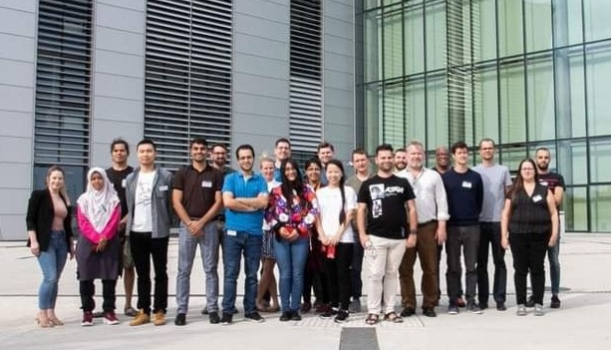

Figure 11: Group photo from the PaNOSC Summer School at ELI-ALPS

The deliverable report 8.4 also acts as a closing report to the work package, with details about the work completed during the project and some outline of what the future will hold for the e-learning platform. Ownership of the e-learning platform has now moved to the Scientific Web Applications team of the ESS DMSC. This will facilitate the long term sustainability of the e-learning platform and ensure that this platform is available for trainers and users. Additionally, this integration into the SWAP team will enable future developments, in particular in the Jupyter integration, that is also driven by requirements for other services at ESS.

Throughout the project, there has been a strong collaboration with our ExPaNDS counterpart (WP5), which has focused on the training catalogue. Through this collaboration it has been possible to ensure a combined front page for the training catalogue and e-learning platform as well as a shared brand identity. Furthermore, all e-learning platform courses are automatically available on the training catalogue.

### WP9 - Outreach/Communication and Dissemination/Impact

In June-November 2022, WP9 has kept interacting with all WP leaders to promote the main outcomes and events in the various WPs through the project’s online channels and mailing lists.

In July, PaNOSC and ExPaNDS jointly organised the online panel discussion “Open Data for healthier societies: a virtuous cycle?” broadcasted live in the ESOF 2022 online platform, as part of the European Science Open Forum programme, targeting science enthusiasts, scientists, journalists, RIs’ staff and managers and science communication specialists. The two sister projects also collaborated to organise the face-to-face internal project meeting held in Prague in June 2022, and their 3rd PaN EOSC Symposium as a satellite event to the ICRI2022 conference in October.

WP9 also significantly supported WP1 in the organisation of the PaNOSC closing event, and WP8 for the Summer School on Material Science at European Large-Scale RIs using Open and FAIR Data.

For wider outreach to the PaN user community, PaNOSC was presented at scientific events, such as the ESS & ILL user meeting, the ELI summer school, the European User Offices Meeting, and more, and continuously involved the LENS and LEAPS initiatives for further promotion.

To further increase the awareness and enhance the adoption of FAIR data practices across the PaN community, some of the services developed have been presented through videos published on the PaNOSC YouTube channel and website, and distributed via PaNOSC and the partners’ social media channels, newsletters and mailing lists:

* PaN Data Commons (event’s recordings):<https://youtu.be/dXUohY0y97A>
* E-learning platform (event’s recordings):<https://youtu.be/DPaSgIru-kA>
* OASYS Software:<https://youtu.be/XP1LJzRTdng>
* VSCode extension to explore and visualize HDF5 files (event’s recordings, with demo):<https://youtu.be/MkOOCO4LFnM>
* McStas (event’s recordings):<https://youtu.be/Ou7dAHhJRn0>

As at 19 October 2022, all PaNOSC published videos reached 4785 views, with a ~20% increase over the previous reporting period. Also, one new factual example (reaching a total of 31) of the use of Jupyter notebooks for e-learning purposes was published.

Collaboration with other EOSC projects also continued. PaNOSC contributed to the roundtable with other EOSC cluster projects at the ESCAPE final conference in October 2022, and organised a panel discussion on the future of the EOSC Data Federation at the 3rd PaN EOSC Symposium at ICRI2022 involving representatives of all clusters.

From the project start, WP9 has been implementing the project communication strategy and plan, revising it in early 2021, to ensure all necessary actions towards a wider engagement of the PaN community of users were properly addressed. News and events content has been continuously shared via the PaNOSC website and social media channels, and also through those of other grants and initatives, such as ExPaNDS, Lightsources.org, LEAPS, LENS, Neutronsources.org, CORDIS (until when active) and the EOSC portal. The internal repositories and a Zenodo account have been set-up and continuously updated with relevant templates, material and publications for the project’s contributors and other collaborating grants and institutions.

PaNOSC’s twitter account has been tweeting regularly with news from the project, related projects and collaborations from the PaN or EOSC community informing about latest news, events or updates (total of 609 tweets and a total of 736 followers recorded on 24.10.2022).

The WP also produced all digital and material assets for the promotion of the project across both online and onsite events. These include videos, interviews, dissemination articles, banners, infographics, digital brochures, posters, presentations, rollups, badges.

Thirty-seven (37) videos have been published, of which 20 interviews with scientists, and RIs’ staff and managers, 5 recordings from events organised or attended by PaNOSC, 3 demos, 3 releases of the ExPaNDS video series on PaNOSC & ExPaNDS, on open data, and on PaN facilities.

Also, the WP contributed to drafting a number of open access publications:

* Enabling Open Science for Photon and Neutron Sources, ICALEPCS2019 Proceedings, JACoW Publishing, August 2020:<https://doi.org/10.18429/JACoW-ICALEPCS2019-TUBPL02>
* PaNOSC key achievements in first 18 months, Zenodo, 2020:<https://doi.org/10.5281/zenodo.4247623>
* PaNOSC – Making FAIR open data a reality for Photon and Neutron Science – Project Repository Journal, October 2022, DOI: https://doi.org/10.54050/PRj1519511
* PaNOSC key achievements, Zenodo, November 2022, DOI: 10.5281/zenodo.7347537

Overall, PaNOSC organised 30 events and actively contributed to 81 events, targeting a wide variety of stakeholders, spanning (early stage) researchers from different communities, data scientists, users of PaN facilities, (e-)RIs’ managers and staff, IT experts, members of the EOSC community and projects, policy makers, representatives of ESFRI and other European bodies, as well as of national and European PaN initiatives, the industry, media and lay publics.

At the end of 2020, PaNOSC launched a call for use cases, for PaN users to submit factual examples of the use of the services developed in PaNOSC and ExPaNDS. The goal was to showcase to other users the current practices in data stewardship, data transfer, (remote) data analysis, data and experiments’ simulation, and of collecting inputs to further improve and develop PaN EOSC services by addressing the specific needs of the research community. The thirty-one use cases received have been published on the project’s website and presented at user meetings, project’s annual meetings and PaN EOSC symposia.

KPIs in WP9 have been continuously monitored, with the goal of further fine-tuning communication and dissemination actions within the project.

The WP has collaborated closely with ExPaNDS to coordinate and harmonise the communications actions, by sharing deliverables and useful resources for communications/outreach. A common events’ calendar and a mailing list have been set-up, with all communication officers from PaNOSC and ExPaNDS partners, to exchange news, info about events and projects’ advancements, useful resources, etc.

The two projects have been supporting each other on social media, and for the organisation of joint events, as well as for the promotion of activities and results. User meetings have been jointly targeted to raise awareness about the projects, and to involve and engage potential and future users of tools / technologies / services developed.

PaNOSC has also actively contributed to the Science Cluster coordination meetings, as well as to other events stimulating the discussion between clusters about the data services developed and possible collaborations to further develop and eventually integrate such services. The main recurrent subjects concerned sustainability of the project outcomes, structuring of the interactions with the EC and the EOSC Association, and participation in the EOSC Future project. In coordination with the FILL2030 H2020 project, a video sponsored by PaNOSC on “The DOI for data” was updated and released, with the agreements of all PaN facilities in Europe, to stimulate the publication of DOIs of datasets in publications.

# PaNOSC Executive Board Meeting - 29/11/2022

The Executive Board (EB) meeting took place on the afternoon of 29th November 2022 and it was attended by representatives (or delegated representatives) from all partners in PaNOSC.

The minutes from the last EB meeting were approved and the current situation of the project reviewed:

* no major issue with regards to deliverables/milestones, with only minor delays
* final periodic report due 29/01/2023
* no review meeting is expected
* project should be completed in budget (according to predictions of final financial reports)

The EB endorsed a proposal from the Coordinator to reassign any unspent funds to partners that end the project with an overspending.

The EB also discussed future collaboration opportunities and the EOSC Procurement tender process, finishing with appreciation from the coordinator and project manager to the EB members for their support during the project. The EB members in turn pointed out that the project was successful in raising the awareness and state of FAIR data in the partner facilities. They also thanked Andy and Jordi for the good management of the project.

# Next steps

PaNOSC has finished after four years of project execution and all the contributors are happy to have delivered mostly on time, on budget and without any major modifications according to the description of work of the grant agreement the project. The outcomes achieved in PaNOSC thanks to the EC funding have made a difference to the PaN community and help build the EOSC. The PaNOSC closing event was a success with over 120 attendees, leading to many interesting conversations and exchanges that are facilitating further collaboration towards sustaining the outcomes of the project and building the EOSC.

PaNOSC partners will attend the ExPaNDS final event and are interested in working with other EOSC-related national initiatives (e.g. DAPHNE4NFDI) and applying for further funding to continue building the EOSC. Initiatives like the Helmholtz Metadata Collaboration have proposed to work with the PaN Data Portal to demonstrate the usefulness of Open Data for AI/ML. PaNOSC and ExPaNDS will continue collaboration on FAIR data as part of the LEAPS and LENS initiatives. These two organisations which together represent the PaN facilities in Europe have endorsed the continuation of the PaNOSC and ExPaNDS outcomes as part of their roadmap. FAIR data and the EOSC are a fundamental part of the LEAPS Data Strategy (to be published in a special issue of the European Journal for Physics plus) for the future.

PaNOSC and ExPaNDS will participate as the PaN cluster in the next series of EOSC calls in Horizon Europe. They will work together with the other clusters on creating competence centres, consolidating the outcomes of PaNOSC and ExPaNDS, sharing solutions and creating synergy amongst the cluster. The main outcomes to be consolidated as part of the EOSC are the PaN Data Commons and VISA platform. Now that PaNOSC and ExPaNDS have implemented the building blocks to make FAIR data at the PaN facilities, ensuring FAIR data is the new normal for PaN scientists will require more work. This work will continue with the help of the EOSC funding and the internal funding of facilities as FAIR data is now an integral part of the services they operate.

1. Photon and Neutron Open Science Cloud: https://www.panosc.eu
2. European Synchrotron Radiation Facility: https://www.esrf.fr/
3. EOSC: European Open Science Cloud
4. FAIR: Findable, Accessible, Interoperable and Reusable
5. PaN: Photon and Neutron
6. Zenodo DOI: 10.5281/zenodo.7390488
7. https://indico.esrf.fr/event/66/
8. <https://github.com/panosc-eu/panosc/tree/master/Work%20Packages/WP1%20Management/Meetings/Project%20Management%20Committee>
9. https://www.panosc.eu/wp-content/uploads/2020/12/D6.1_DataHub.pdf